# **Acqua di Gioia**

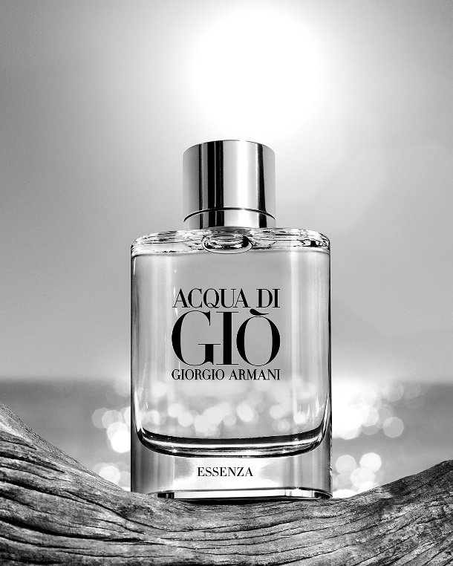Acqua di Gioia by Giorgio Armani is a Floral Aquatic fragrance for women. Acqua di Gioia was launched in 2010. Acqua di Gioia was created by Loc Dong, Anne Flipo and Dominique Ropion. Top notes are Amalfi Lemon and Mint; middle note is Water Jasmine; base notes are Virginia Cedar, Brown sugar and French labdanum.

Acqua di Gioia is a new fragrance by Giorgio Armani, presented in March 2010. Seductive sea aromas in the new fragrance are put into first plan and used as creators' inspiration. Composition of the perfume is compared with woman who is ''strong, dignified and free spirit but in perfect harmony with nature''.